**Markeita’s Medium Flag**

**The last one to figure out this flag is the ___ egg.**

*Hint- The missing word is a clue that will lead you to the next step.

[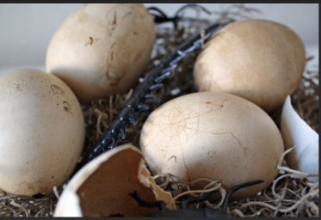](uggcf://tvguho.pbz/plorexvpxonpxPGS/Znexrvgnf_Syntqnl)